

ASSIGNMENT NO : 01

Software Construction And Development

**Name : BILAL NAEEM ABBASI**

**Reg.No : 4110-FBAS/BSSE/F20**

**Submitted to : Prof. Shakir Rasheed**

**Question:**

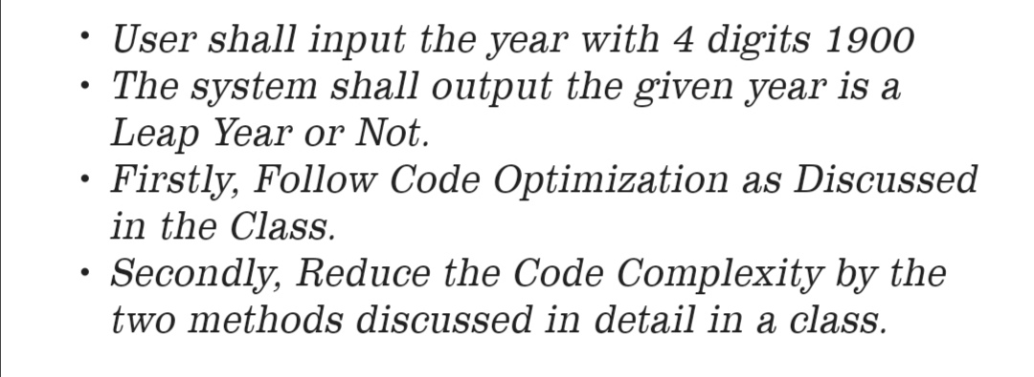

## **CODE :**

import java.util.Scanner;

public class LeapYear {

public static void main(String[] args) {

Scanner input = new Scanner(System.in);

int year;

char choice;

do {

System.out.print("Enter a year: ");

year = input.nextInt();

boolean isLeap = isLeapYear(year);

if (isLeap) {

System.out.println(year + " is a leap year.");

} else {

System.out.println(year + " is not a leap year.");

}

System.out.print("Do you want to check another year? (Y/N): ");

choice = input.next().charAt(0);

} while (Character.toUpperCase(choice) == 'Y');

input.close();

}

public static boolean isLeapYear(int year) {

if (year % 4 != 0) {

return false;

} else if (year % 100 != 0) {

return true;

} else if (year % 400 != 0) {

return false;

} else {

return true;

}

}

}

# **Output**

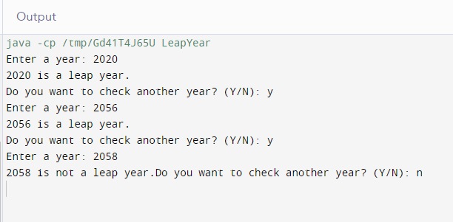

**THANK YOU**